CS540

Matthew Getter

**Instructions/Description**

**How to Install FCC Towers to Postgres and QGIS**

Please use these instructions in conjunction with the guided video.

1. Go to my Github:

<https://github.com/Dancekonig/CS540-Task3.git>

Download the zip file “fcctowers.zip”, then extract into: c:\temp\cs540\gis .

1. Edit the get_load batch file in gis folder, type/copy:



1. Then run this code in CMD . (# This loads data to Postgres (pg Admin))

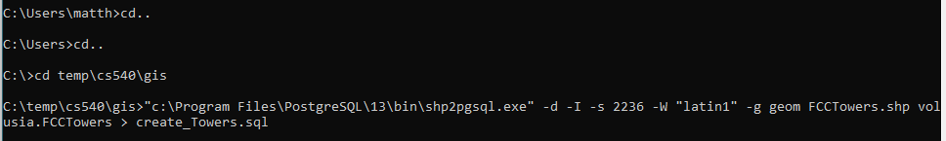



This is the attribute table in pg admin to understand the columns and values in dataset.

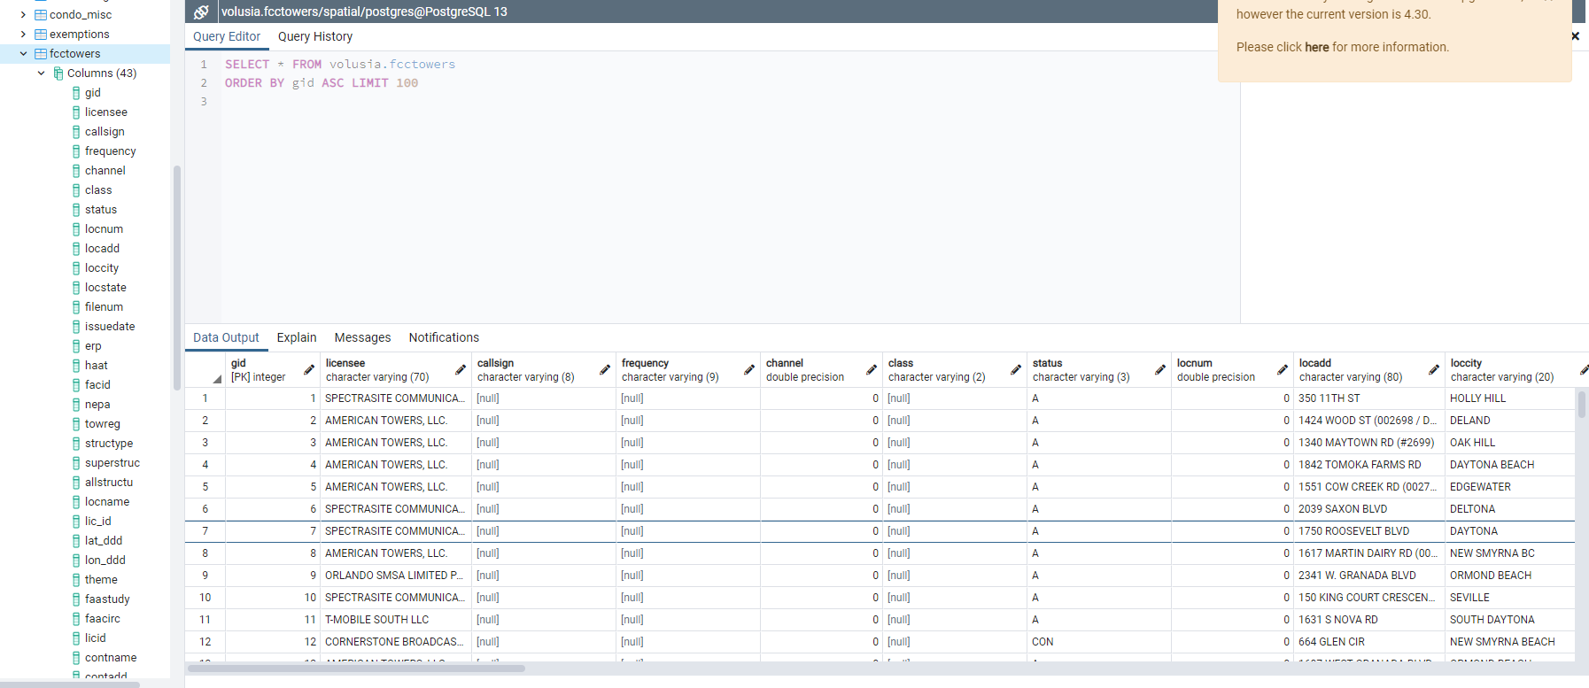

1. Open QGIS and add a PostGIS Layer with the connected “fcctowers” dataset.

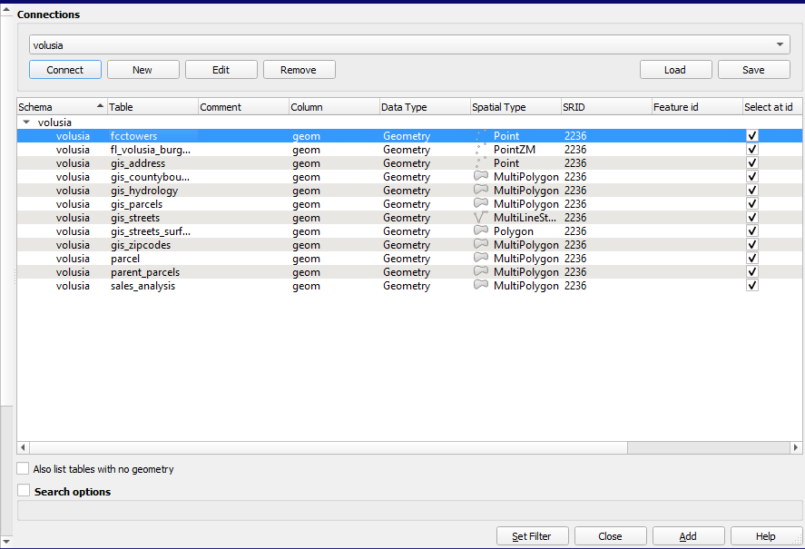

1. Once the “fcctowers” layer is added, Open DBManager and run any of the following Queries: (# This will find the 15 closest FCC Towers to the desired altkey)

Any of these quries show the same results. (# Confirmation with fcctower layer.)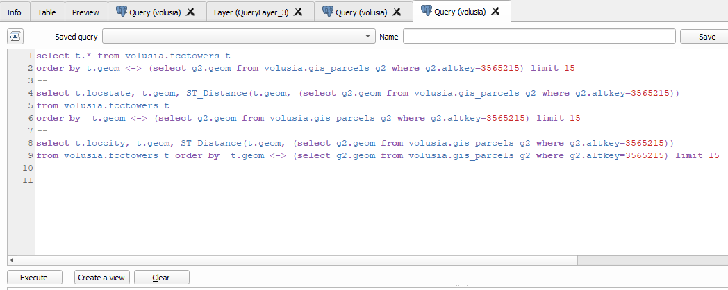

1. **(optional)** change the properties and symbology of new Qgis Layers to get: a buffer for Cell area coverage. Distance to a tower if a residence is too close for health reasons.

These buffers can be added in two easy ways. The third way can be done via SQL but requires definitive x,y gis points to create a single buffer.

First way: Choose circle shape in properties and use ‘Meters at scale’. (#Double the desired distance for accuracy. Eg. For 300M area you put 600 in Size.)

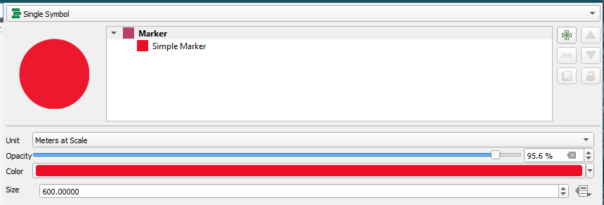

Second Way: Vector>Geoprocessing Tools> Buffer. (# This is just a temporary layer.)

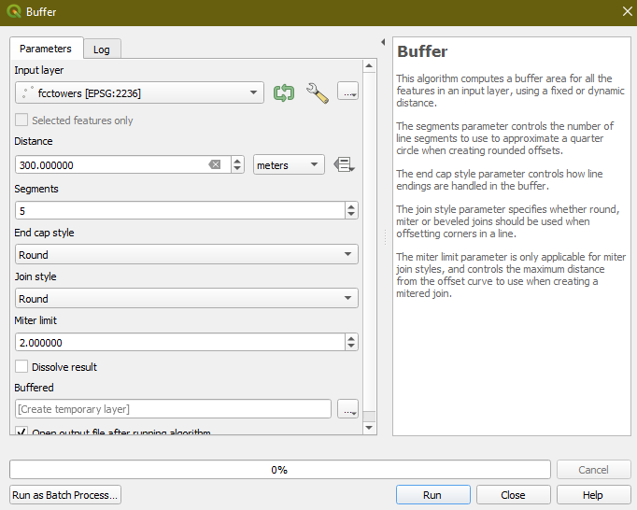

1. **End Results:**

The following pictures should show the same results as instructed above:

15 closest FCC towers to Embry Riddle:

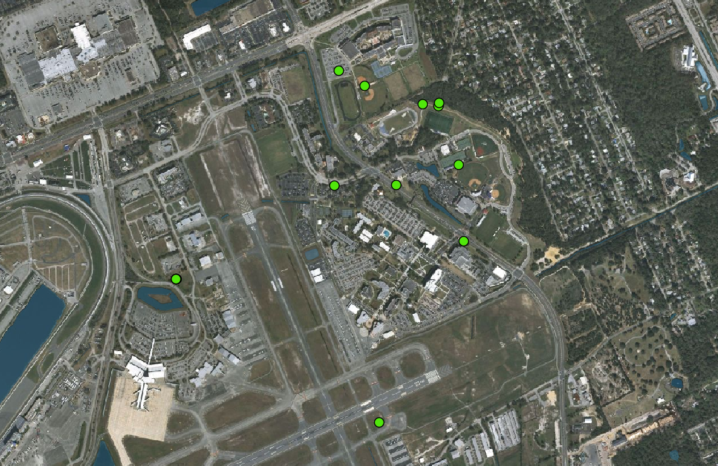

Show all Towers for confirmation (overlap):

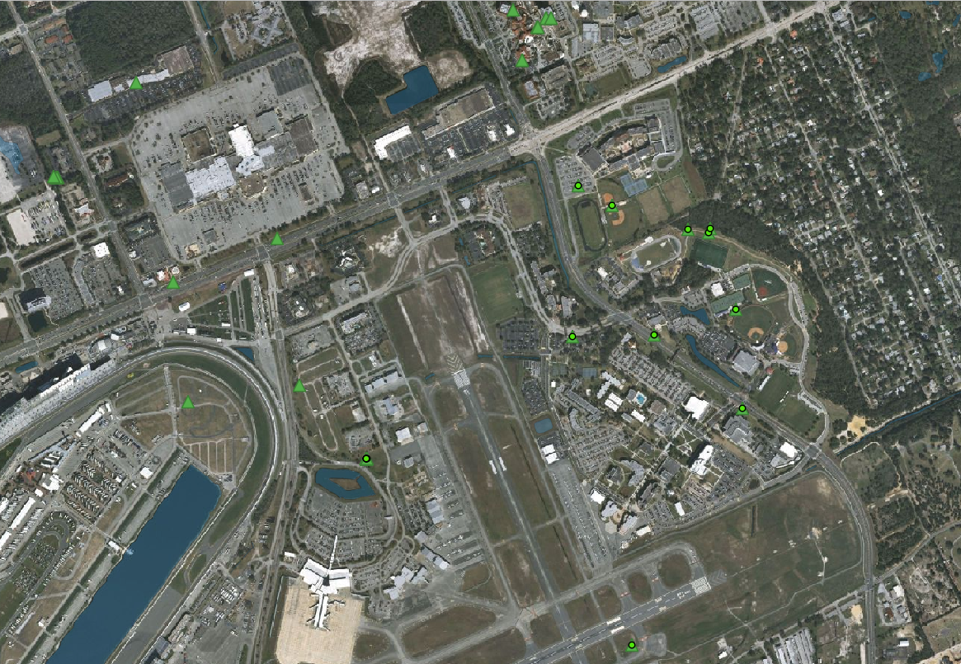

With Optional Symbology/Properties, find a buffer: Red depicting health risk @300M radius and Yellow @600M radius presenting a medium/cautionary zone for a living area.

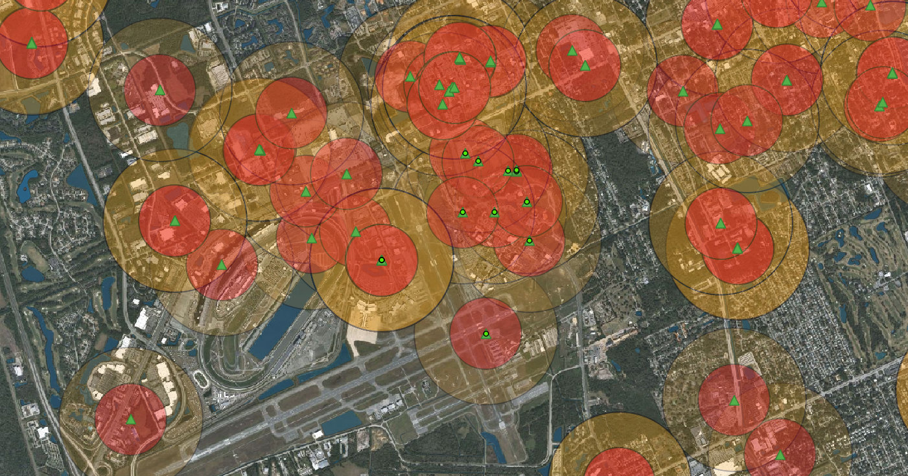

Finding Maximum Cell area coverage (w/ overlap) @ 35405 Meters:

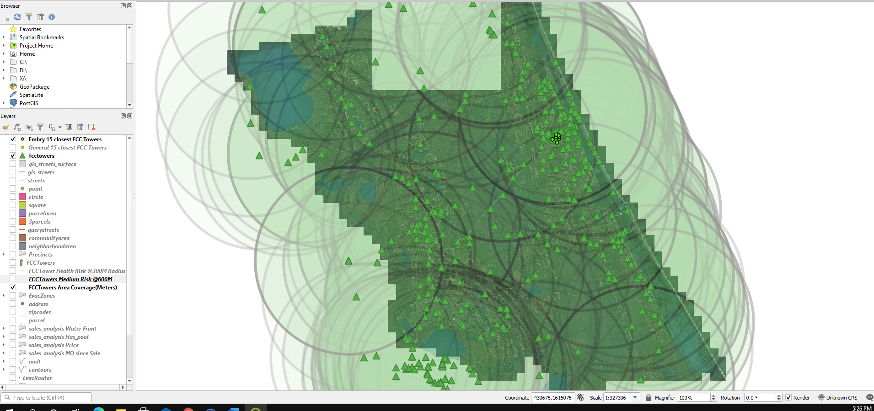

END